**Expense Accountancy Tracking**

By

Mahavadia Krutika

140174107016

Aakash Bhatia

140174107001



DEPARTMENT OF COMPUTER ENGINEERING

VISHWAKARMA GOVERNMENT ENGINEERING COLLEGE CHANDKHEDA

**Expense Accountancy Tracking**

Submitted in partial fulﬁllment of the requirements for the degree of Bachelor of Engineering in Computer Enginering

By

Mahavadia Krutika

140174107016

Aakash Bhatia

140174107001



DEPARTMENT OF COMPUTER ENGINEERING

VISHWAKARMA GOVERNMENT ENGINEERING COLLEGE CHANDKHEDA

**Declaration**

This is to certify that

i) The project comprises my original work towards the degree of bachelor of En­gineering in Computer Engineering at Vishwakarma Government Engineering College, Chandkheda, under the Gujarat Technological University, Ahmedabad and has not been submitted elsewhere for a degree.

ii) Due acknowledgement has been made in the text to all other material used.

Mahavadia Krutika

**Declaration**

This is to certify that

i) The project comprises my original work towards the degree of bachelor of En­gineering in Computer Engineering at Vishwakarma Government Engineering College, Chandkheda, under the Gujarat Technological University, Ahmedabad and has not been submitted elsewhere for a degree.

ii) Due acknowledgement has been made in the text to all other material used.

Aakash Bhatia

**Certiﬁcate**

This is to certify that the Project entitled ”Expense Accountancy tracking” submitted by Mahavadia Krutika (14017310716), towards the partial fulﬁllment of the requirements for the degree of Bachelor of Engineering in Information Technology of Vishwakarma Government Engineering College, Chandkheda, under the Gujarat Technological University, Ahmedabad is the record of work carried out by him under my supervision and guidance. In my opinion, the submitted work has reached a level required for being accepted for examination. The results embodied in this project, to the best of my knowledge, haven’t been sub­mitted to any other university or institution for award of any degree or diploma.

|  |  |
| --- | --- |
| **External Guide**  Signature:  Name:  Designation:  Organization: | **Internal Guide**  Signature:  Name: Ms. Zalak P Bhatt  Designation:  Organization: |
| **Head of Department**  Prof. M.T.Savaliya,  Associate Professor  Computer Engineering Department,  Vishwakarma government engineering college, Chandkheda, Ahmedabad. | **Signature of External Examiner** |

**Certiﬁcate**

This is to certify that the Project entitled ”Expense Accountancy tracking” submitted by Bhatia Aakash (140173107001), towards the partial fulﬁllment of the requirements for the degree of Bachelor of Engineering in Information Technology of Vishwakarma Government Engineering College, Chandkheda, under the Gujarat Technological University, Ahmedabad is the record of work carried out by him under my supervision and guidance. In my opinion, the submitted work has reached a level required for being accepted for examination. The results embodied in this project, to the best of my knowledge, haven’t been sub­mitted to any other university or institution for award of any degree or diploma.

|  |  |
| --- | --- |
| **External Guide**  Signature:  Name:  Designation:  Organization: | **Internal Guide**  Signature:  Name: Ms. Zalak P Bhatt  Designation:  Organization: |
| **Head of Department**  Prof. M.T.Savaliya,  Associate Professor  Computer Engineering Department,  Vishwakarma government engineering college, Chandkheda, Ahmedabad. | **Signature of External Examiner** |

**Abstract**

“Expense Accountancy Tracking” is a “family based accountancy tracking system” or we can say a “family based expense manager”, which is based on device running android operating system.

The main idea beside developing this type of system is to allow parents to track their childrens day-to-day minute expenses. Many of the teenager students are encountered to have addiction to drugs, alcohol, tobacco and cigarettes; due to which many of them had either died or spoiled there life which at last impact on parents highly. Thus parents along with their management of expenses they also can tarack their another family members expenses and there by detecting and eliminating such addictions.

In existing manual system of managing expense by writing expenses on pages or in books the disadvantage is the pages or book can get misplaced easily which lead user in stress, even finding any expense in pages or book is too difficult task, and thus managing these pages and books is very difficult; while using this app user will manage everything on their finger tips and also whole data will be synchronized on app server where data is secure and available anytime anywhere.

**Acknowledgements**

The satisfaction that accompanies that the successful completion of any task would be incomplete without the mention of people whose ceaseless cooperation made it possible, whose constant guidance and encouragement crown all efforts with success.

We are grateful to our project guide Ms. Zalak P Bhatt for the guidance, inspiration and constructive suggestions that helpful us in the preparation of this project.

We also thank our colleagues Nikhil suthar and others who have helped in successful completion of the project.

* Mahavadia Krutika

140173107016

* Bhatia Aakash

140174107001

**Table of Content**

1. Introduction
   1. Project Summary
   2. Objective
   3. Scope
   4. Technology Used
   5. Hardware-Software used
2. System Analysis
   1. Study of current System
   2. Problem and weakness of Current System
   3. Requirement of New System
   4. Feasibility Study
3. Project Management
   1. Project Planning and Scheduling
      1. Project Development Approach
      2. Project Plan
      3. Schedule Representation
      4. Roles and Responsibilities
   2. RiskManagement
      1. RiskIdentification
      2. Riskanalysis
      3. Riskplanning
4. System Modeling
   1. Dataflow diagrams.
      1. Context Level Diagram
      2. Level - 1 DFD
      3. Level – 2 DFD
   2. Use case diagrams
   3. Activity Diagrams
   4. Sequence diagrams
   5. Class Diagrams
5. Data modeling and design
   1. Data dictionary
   2. Database Relationship Diagram
6. Screenshots
7. Testing
   1. Test cases (for each module)
8. Limitation and Future Enhancement
9. Conclusion
10. Bibliography and References

**1. Introduction**

**1.1. Project Summary**

“Expense Accountancy Tracking” is a “family based accountancy tracking system” or we can say a “family based expense manager”, which is based on device running android operating system. Here each family member can enter their minute detailes of their evry small to big expenses in their android device and thereby maintain an online record of their expenses which can be then tracked by them and head member of family.

This app provides feature to track each and every expense of all family member by head member, Thus here head member can track all expense of other family members. There can be multiple or all family members be head members. Head member only has authorities to track other members expenses of his family, other normal user can track only their own expenses.

Except this app also provide an interactive user interface with different type of report generation and representation, also different types of calculatos are also available in app for user so that user can perform their calculations while be working within the app only. User can also set their saving targets in app and feedc daily saved amount datato acieve their targets. While adding expenses user can select category of expense, amount of expense, way that user paid expense, bill image, date and time, etc.

**1.2. Objective**

The main idea beside developing this type of system is to allow parents to track their childrens day-to-day minute expenses. Many of the teenager students are encountered to have addiction to drugs, alcohol, tobacco and cigarettes; due to which many of them had either died or spoiled there life which at last impact on parents highly. Thus parents along with their management of expenses they also can tarack their another family members expenses and there by detecting and eliminating such addictions.

Another objectives like In existing manual system of managing expense by writing expenses on pages or in books the disadvantage is the pages or book can get misplaced easily which lead user in stress, even finding any expense in pages or book is too difficult task, and thus managing these pages and books is very difficult; while using this app user will manage everything on their finger tips and also whole data will be synchronized on app server where data is secure and available anytime anywhere.

**1.3. Scope**

This system will consist of functionality to add user’s expenses along with images of bill, allow to maintain expense record online, allow to track there own expenses, view different type of reports based on time or category of expense, allows head user to track other user of family, reduce paper work, reduce manual maintenance of expenses records, easy to find any expense, and also allows user to set saving target and track their tatgets achievement progress.

**1.4. Technology Used**

|  |  |
| --- | --- |
| Project title : | Expense Accountancy Tracking |
| Front end: | Android(4.1.x & above) |
| Back end: | Java Web Services |
| Database: | MySql |

**1.5. Hardware-Software used**

|  |  |
| --- | --- |
| Project title : | Expense Accountancy Tracking |
| Hardware | NA |
| Software | * Android Studio * Netbeans * Mysql database server. |

**2. System Analysis**

**2.1. Study of current System**

* Current manual legacy system requires lots of manual work that results in stress, boredom, extra overhead etc,
* Another existing apps are limited up to tracking of user’s own expenses only,
* Another existing apps are limited to use for employers, employee and any single user only; no family tracking functionalities available and no family centered management of expenses,
* Manual system does not have any kind of back up for the expense data and difficult to achieve data backup facility is very,
* In manual system there are very high rate of data redundancy.

**2.2. Problem and weakness of Current System**

* Lots of manual work in existing manual system,
* Limited up to tracking of user’s own expenses only,
* Limited use upto employers, employee and any single user only
* No family tracking functionalities available,
* No family centered management of expenses,
* Data backup facility is very in existing manual system,
* Very high rate of data redundancy in existing manual system.

**2.3. Requirement of New System**

* To educed paper work,
* To track family other members expenses,
* No limited use upto employers, employee and any single user only,
* Family centered management of expenses,
* Data backup facility,
* To Reduce rate of data redundancy.

**2.4. Feasibility Study**

Feasibility study is made to see if the project on completion will serve the purpose of the organization for the amount of work, effort and the time that spend on it. Feasibility study lets the developer foresee the future of the project and the usefulness. A feasibility study of a system proposal is according to its workability, which is the impact on the organization, ability to meet their user needs and effective use of resources. Thus when a new application is proposed it normally goes through a feasibility study before it is approved for development.

The document provide the feasibility of the project that is being designed and lists various areas that were considered very carefully during the feasibility study of this project such as Technical, Economic and Operational feasibilities. The following are its features:

**2.4.1 Technical Feasibility:**

The system must be evaluated from the technical point of view first. The assessment of this feasibility must be based on an outline design of the system requirement in the terms of input, output, programs and procedures. Having identified an outline system, the investigation must go on to suggest the type of equipment, required method developing the system, of running the system once it has been designed.

Technical issues raised during the investigation are:

* + Does the existing technology sufficient for the suggested one?
  + Can the system expand if developed?

The project should be developed such that the necessary functions and performance are achieved within the constraints. The project is developed within latest technology. Through the technology may become obsolete after some period of time, due to the fact that newer version of same software supports older versions, the system may still be used. So there are minimal constraints involved with this project. The system has been developed using Java the project is technically feasible for development.

We as Analysts have identified the existing computer systems (hardware & software) of the concerned department and have determined whether these technical resources are sufficient for the proposed system or not.We have found out thus, that the project is technically very much feasible*.*

**2.4.2 Economic Feasibility:**

The developing system must be justified by cost and benefit. Criteria to ensure that effort is concentrated on project, which will give best, return at the earliest. One of the factors, which affect the development of a new system, is the cost it would require.

The following are some of the important financial questions asked during preliminary investigation:

* The costs conduct a full system investigation.
* The cost of the hardware and software.
* The benefits in the form of reduced costs or fewer costly errors.

Since the system is developed as part of project work, there is no manual cost to spend for the proposed system. Also all the resources are already available, it give an indication of the system is economically possible for development.

**2.4.3 Behavioral Feasibility:**

This includes the following questions:

* Is there sufficient support for the users?
* Will the proposed system cause harm?

The project would be beneficial because it satisfies the objectives when developed and installed. All behavioral aspects are considered carefully and conclude that the project is behaviorally feasible.

**3. Project Management:**

Project management is the application of processes, methods, knowledge, skills and experience to achieve the project objectives.

A project is a unique, transient endeavor, undertaken to achieve planned objectives, which could be defined in terms of outputs, outcomes or benefits. A project is usually deemed to be a success if it achieves the objectives according to their acceptance criteria, within an agreed timescale and budget.

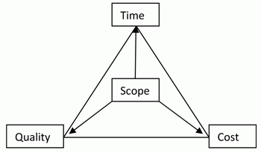

**The core components of project management are:**

* Defining the reason why a project is necessary;
* Capturing project requirements, specifying quality of the deliverables, estimating resources and timescales;
* Preparing a business case to justify the investment;
* Securing corporate agreement and funding;
* Developing and implementing a management plan for the project;
* Leading and motivating the project delivery team;
* Managing the risks, issues and changes on the project;
* Monitoring progress against plan;
* Managing the project budget;
* Maintaining communications with stakeholders and the project organization;
* Closing the project in a controlled fashion when appropriate.

**3.1 Project Planning and Scheduling:**

**Project Planning:**

Project planning is a procedural step in project management, where required documentation is created to ensure successful project completion. Documentation includes all actions required to define, prepare, integrate and coordinate additional plans. The project plan clearly defines how the project is executed, monitored, controlled and closed.

Project planning requires an in-depth analysis and structuring of the following activities:

* Setting project goals
* Identifying project deliverables
* Creating project schedules
* Creating supporting plans

**Project Scheduling:**

Project Scheduling in a project refers to roadmap of all activities to be done with specified order and within time slot allotted to each activity. Project managers tend to define various tasks, and project milestones and them arrange them keeping various factors in mind. They look for tasks lie in critical path in the schedule, which are necessary to complete in specific manner (because of task interdependency) and strictly within the time allocated. Arrangement of tasks which lies out of critical path are less likely to impact over all schedule of the project.

**For scheduling a project, it is necessary to -**

* Break down the project tasks into smaller, manageable form,
* Find out various tasks and correlate them,
* Estimate time frame required for each task,
* Divide time into work-units,
* Assign adequate number of work-units for each task,
* Calculate total time required for the project from start to finish.

**3.1.1 Project Development Approach:**

Sometimes there seem to be as many project approaches as there are projects. How to choose the right approach for a project is a large topic in itself. The methodology you choose can depend on many things, including the structure and location of the project team, the technologies being used on the project, and the degree to which collaboration is a part of the company’s culture. For the purposes of this book, we’re assuming that you’ve joined a project where the approach has largely been determined by those responsible for the project’s success, such as the project sponsor and project manager. In this situation, your main goal will be to understand the approach and help make it effective for the business stakeholders and your users.

The important thing to note is that most approaches involve the same steps:

* Plan the overall strategy, approach, and team structure.
* Define the project requirements.
* Design interaction and visual concepts and evolve them into detailed specifications.
* Develop, test, and refine the solution.
* Deploy the solution via messaging, training, and a planned launch.
* Extend the project by making recommendations for improvements.

**3.1.2 Project Plan:**

A project plan is a formal document designed to guide the control and execution of a project. A project plan is the key to a successful project and is the most important document that needs to be created when starting any business project.

A project plan answers the following basic questions regarding the project:

* Why? - What is the task related to the project? Why is the project is being sponsored?
* What? - What are the activities required to successfully complete the project? What are the main products or deliverables?
* Who? - Who will take part in the project and what are their responsibilities during the project? How can they be organized?
* When? - What exactly is the project schedule and when can the milestones be completed?

**3.1.3 Schedule Representation:**

The goal of a software project schedule is to determine the duration of the software project and the phases within the project. A software project schedule enables you to distribute the estimated effort to be spent in performing the critical activities.

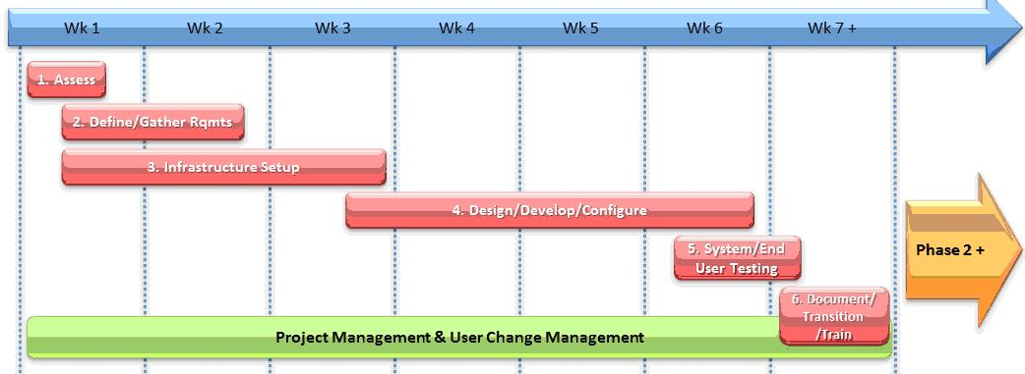

Some of the guidelines for creating a software project schedule are discussed below:

* **Classification:** While managing a software project, you need to group similar tasks and activities so that they are completed successfully. The primary tools used to group similar tasks are the WBS and decomposition technique. Using these tools, you can divide a software project into different phases. The phases can be further subdivided into activities. The software project schedule is prepared according to the arrangement of the phases.
* **Interdependence:** As you have seen, a software project is composed of multiple phases and each phase is composed of multiple activities. Although each activity is treated separately, it is linked to other activities. As a project manager, you determine the interdependence and sequence of activities. For example.
* **Time and effort allocation:** Each activity in a software project needs a certain amount of time and effort for completion. To manage the project, you assign start and end dates to each activity. You also need to allocate appropriate effort to each activity. Most software projects operate with time and effort constraints. Therefore, managing within the available resources is very important for a software project manager.
* **Validation criteria:** You also determine the validation criteria for time and effort allocation in a software project. Determining the validation criteria allows you to ensure that the optimal level of resources is available for a particular activity. Suppose 5 people are assigned to an activity that requires an effort of 3.5 person days. This means resources allocated are more than the actual requirement.
* **Defined responsibilities and outputs:** As a software project manager, you assign roles and responsibilities to all people assigned to a software project. This defines the hierarchy in the development team. You also define the outputs from each activity. This helps in identifying the results expected at the end of every activity.

**3.1.4 Roles and Responsibilities:**

**Roles:**

* **Project Manager:** The person responsible for developing, in conjunction with the Project Sponsor, a definition of the project. The Project Manager then ensures that the project is delivered on time, to budget and to the required quality standard (within agreed specifications).
* **Project Sponsor:** The person who commissions others to deliver the project and champions the cause throughout the project.
* **Project Team Members:** The staff who actively work on the project, at some stage, during the lifetime of the project. Some may have a specific role – for example, the Team might include a Project Administrator.
* **System Developer:** To work with the Project Manager on defining and executing development requirements.

**Responsibilities:**

* Managing and leading the project team.
* Recruiting project staff and consultants.
* Managing co-ordination of the partners and working groups engaged in project work.
* Acts as champion of the project.
* Is accountable for the delivery of planned benefits associated with the project.
* Ensures resolution of issues escalated by the Project Manager or the Project Board.
* Provide functional expertise in an administrative process.
* Work with users to ensure the project meets business needs.
* Documentation and analysis of current and future processes/systems.
* Identification and mapping of information needs.
* Defining requirements for reporting and interfacing.

**3.2 Risk Management:**

Risk is an expectation of loss, a potential problem that may or may not occur in the future. It is generally caused due to lack of information, control or time.A possibility of suffering from loss in software development process is called a software risk.

Risk management is the process of identification, analysis and acceptance or mitigation of uncertainty in investment decisions. Risk management is carried out to:

1. Identify the risk
2. Reduce the impact of risk
3. Reduce the probability or likelihood of risk
4. Risk monitoring

**3.2.1 Risk Identification:**

In order to identify the risks that your project may be subjected to, it is important to first study the problems faced by previous projects. Study the project plan properly and check for all the possible areas that are vulnerable to some or the other type of risks. The best ways of analyzing a project plan is by converting it to a flowchart and examine all essential areas. It is important to conduct few brainstorming sessions to identify the known unknowns that can affect the project. Any decision taken related to technical, operational, political, legal, social, internal or external factors should be evaluated properly.

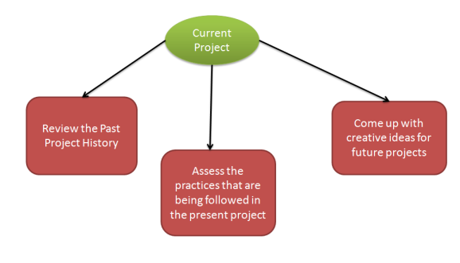

In this phase of Risk management, you have to define processes that are important for risk identification. All the details of the risk such as unique Id, date on which it was identified, description and so on should be clearly mentioned.

**3.2.2 Risk Analysis:**

Software Risk analysisis a very important aspect of risk management. In this phase the risk is identified and then categorized. After the categorization of risk, the level, likelihood (percentage) and impact of the risk is analyzed. Likelihood is defined in percentage after examining what are the chances of risk to occur due to various technical conditions. These technical conditions can be:

1. Complexity of the technology,
2. Technical knowledge possessed by the testing team,
3. Conflicts within the team,
4. Teams being distributed over a large geographical area,
5. Usage of poor quality testing tools.

With impact we mean the consequence of a risk in case it happens. It is important to know about the impact because it is necessary to know how a business can get affected:

1. What will be the loss to the customer?,
2. How would the business suffer?,
3. Loss of reputation or harm to society,
4. Monetary losses,
5. Legal actions against the company,
6. Cancellation of business license.

**3.2.3 Risk Planning:**

Software risk planning is all about:

1. Defining preventive measure that would lower down the likelihood or probability of various risks.
2. Define measures that would reduce the impact in case a risk happens.
3. Constant monitoring of processes to identify risks as early as possible.

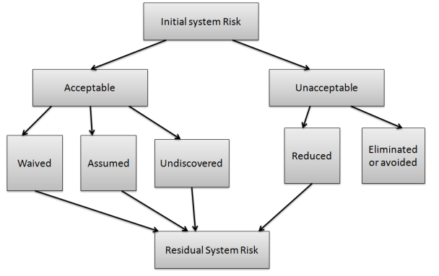

**3.2.4 Risk Monitoring:**

Software risk monitoring is integrated into project activities and regular checks are conducted on top risks. Software risk monitoring comprises of:

* Tracking of risk plans for any major changes in actual plan, attribute, etc.
* Preparation of status reports for project management.
* Review risks and risks whose impact or likelihood has reached the lowest possible level should be closed.
* Regularly search for new risks.

**4. System Modeling**

**4.1. Dataflow diagrams**

**4.1.1. Context Level Diagram**

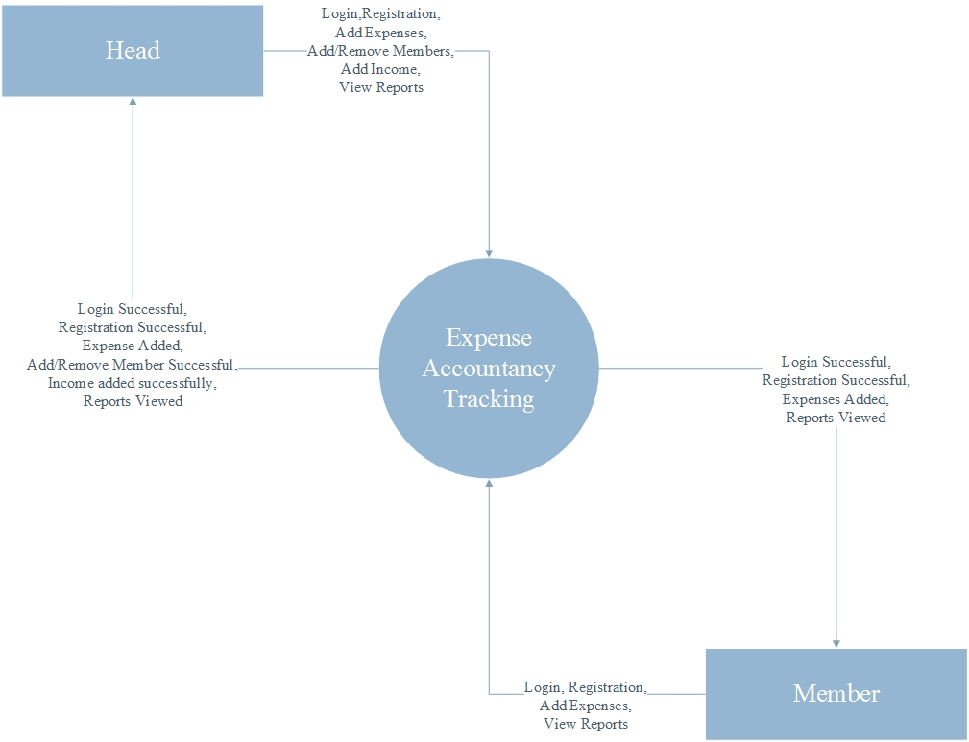

**4.1.2. Level - 1 DFD**

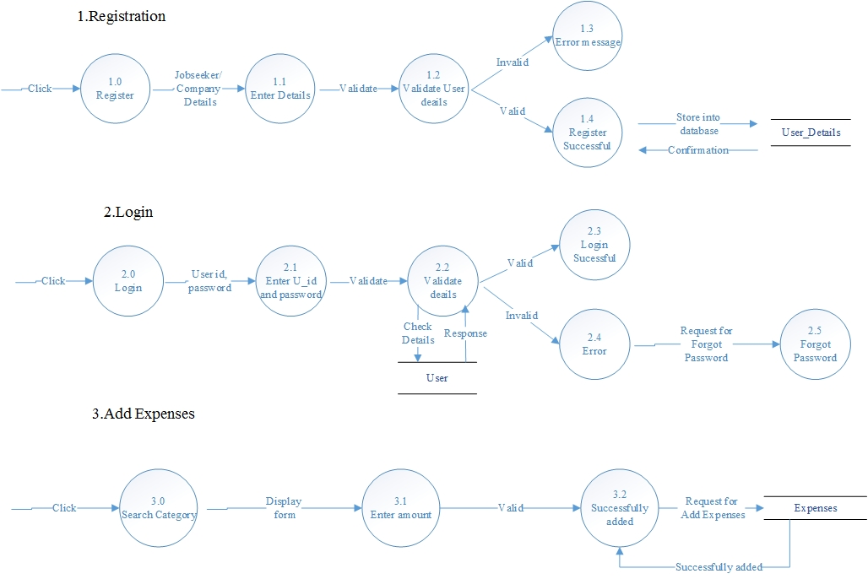

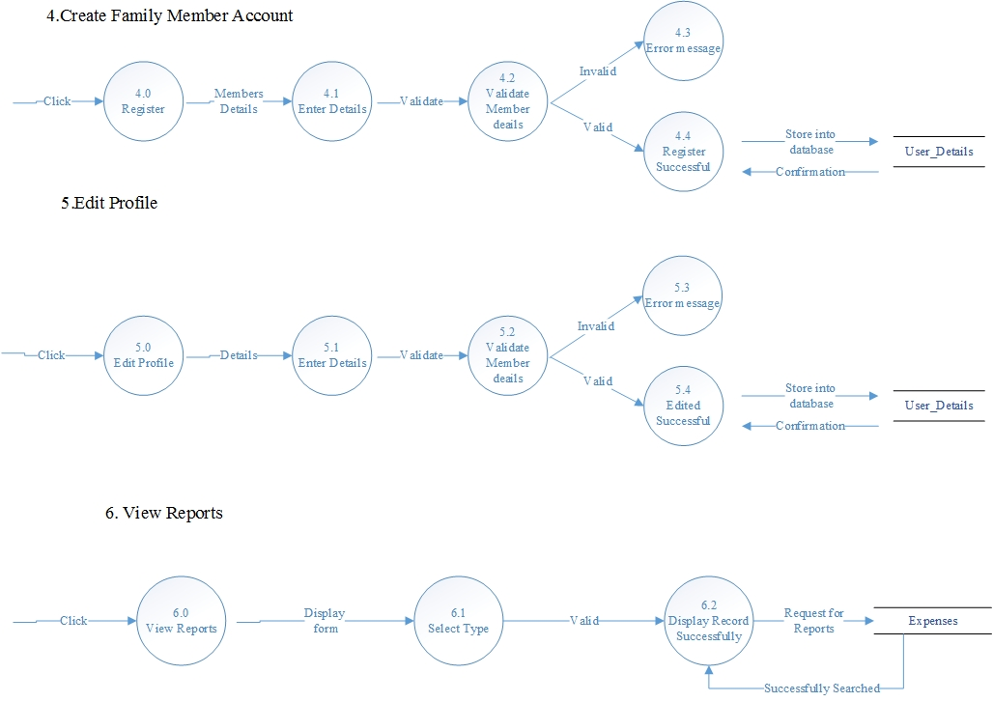

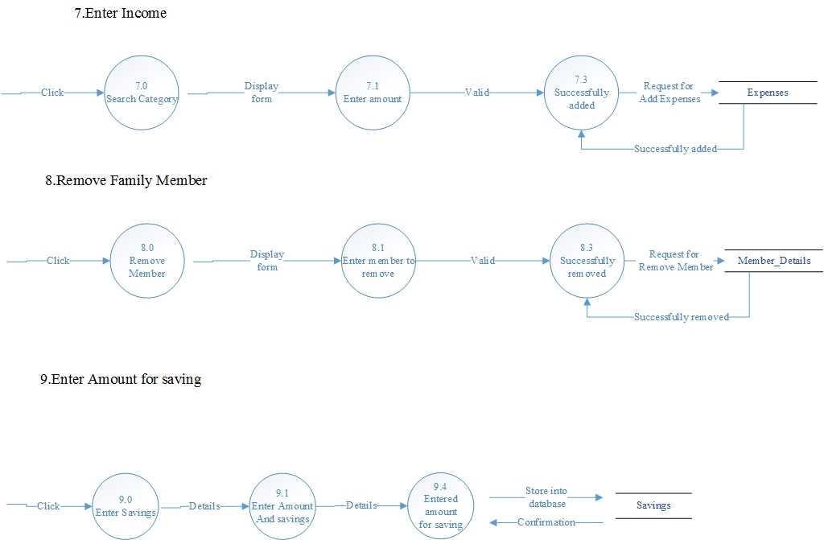

**4.1.3. Level - 2 DFD**

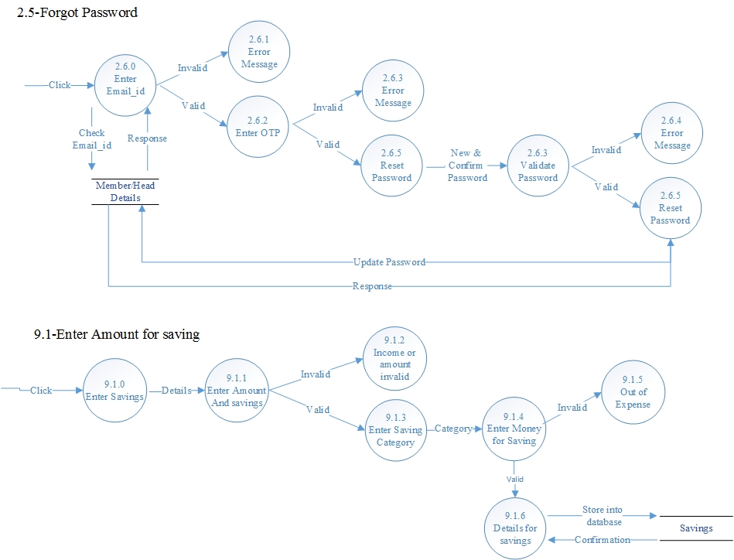

**4.2. Use case diagram**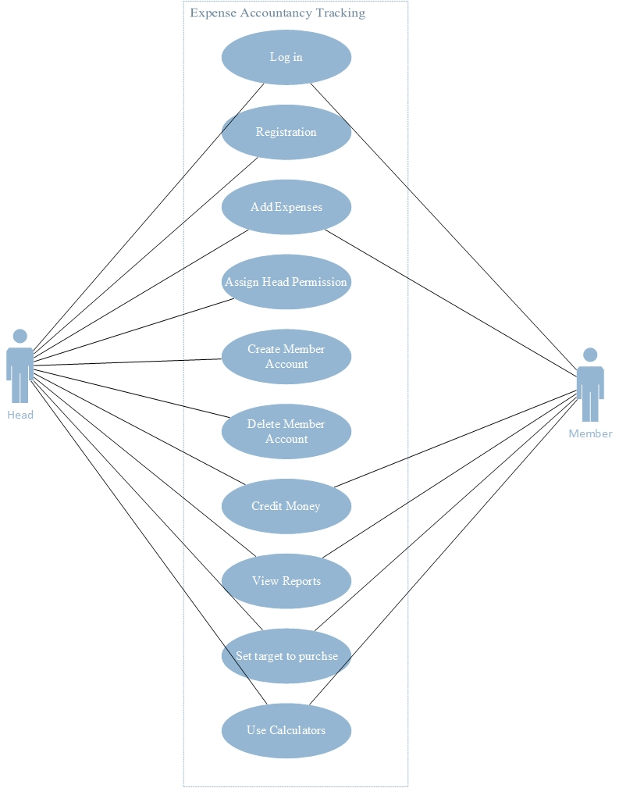

Here Head user can perform all activitiers that a normal member user can and along with that “Assign head permission”, ”Create member account”, ”Delete member account”, etc. normal member and head user can perform “Login”, ”Registration”, ”Add expense”, ”Credit money”, ”View reports”, ”Set target to purchase”, ”Use calculator”.

**4.3. Activity Diagram**

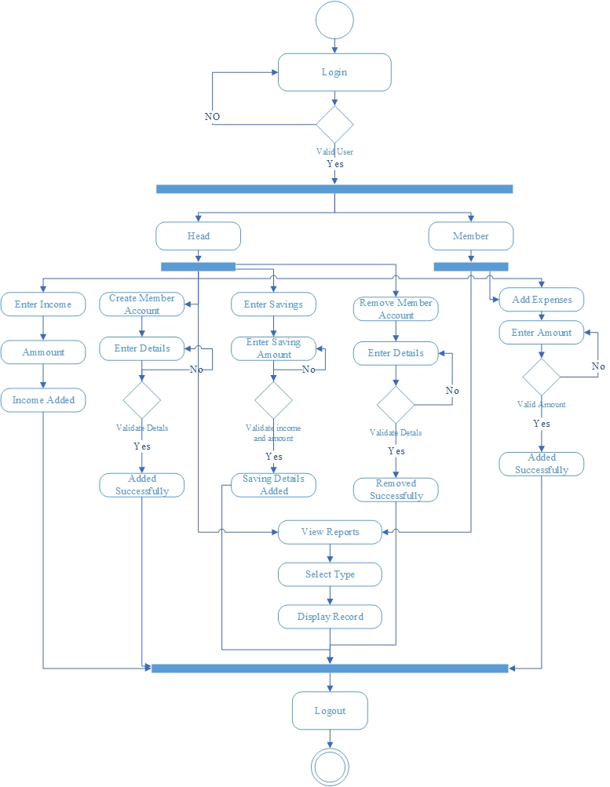

**4.4. Sequence diagrams**

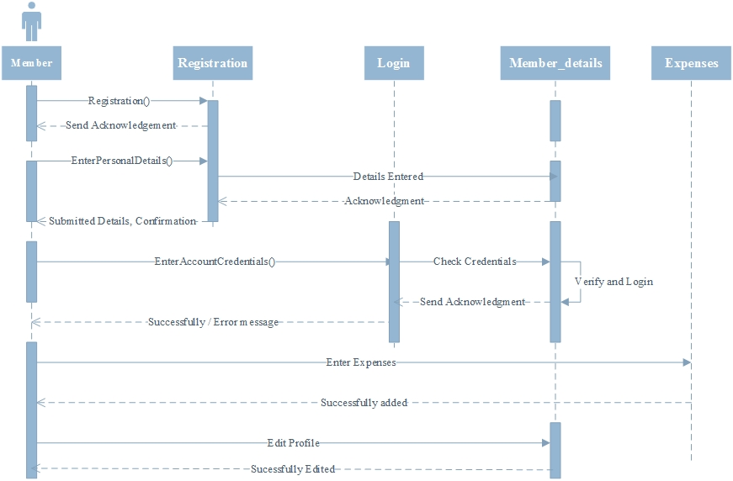

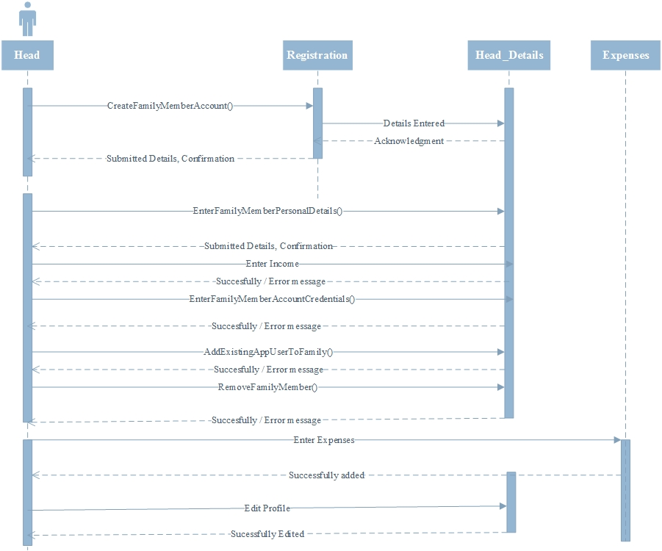

**4.5. Class Diagram**

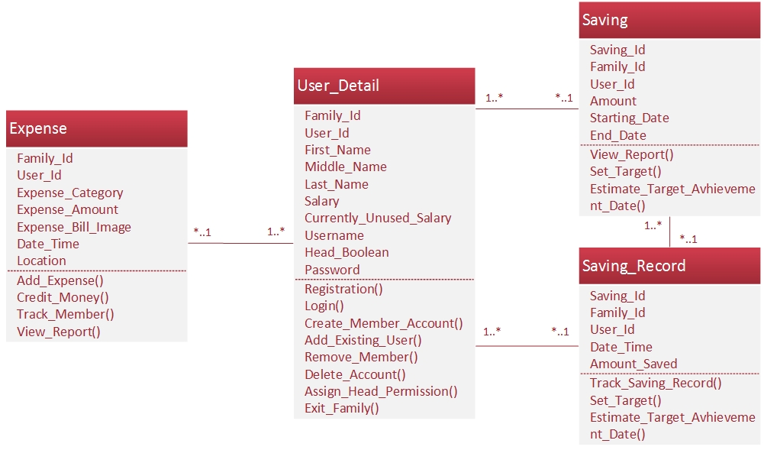

**5. Data modeling and design**

**5.1. Data dictionary**

|  |  |  |  |  |  |  |  |
| --- | --- | --- | --- | --- | --- | --- | --- |
| Entity name | Entity description | | | | | | |
| Column name | **Column description** | **Data**  **type** | **Length**  **(Bytes)** | **Primary**  **key** | **Allow**  **Null** | **unique** |
| User_detail | **All users details will be maintained here in this table** | | | | | | |
| Family_Id | Uniquely identify a family | Integer |  | Composite Primary Key | no | no |
| User_Id | Uniquely identify an user within family | Integer | 4 | no | no |
| First_Name | First name of user | String | - | - | no | no |
| Middel_Name | Middle name of user | String | - | - | yes | no |
| Last_Name | Last name of user | String | - | - | yes | no |
| Salary | Monthly salary of user | Integer | 4 | - | no | no |
| Currently_Unused_Salary | Unused amount of salary of user | Integer | 4 | - | no | no |
| Username | Username of user unique for all user’s | String | - | - | no | yes |
| Head | Define either user is head user or not | Boolean | 1bit | - | no | no |
| Password | Account password of user | String | - | - | no | no |
| Email | Email id of user | String | - | - | no | yes |
| Expense | **All expenses of user’s will be recoded here** | | | | | | |
| Expernse_Id | Uniquely identify an expense | Integer | 4 | Composite Primary Key | no | yes |
| Family_Id | Uniquely identify a family | Integer | 4 | no | no |
| User_Id | Uniquely identify an user within family | Integer | 4 | no | no |
| Expense_Category | Category of expense | String | - | - | no | no |
| Expense_Amount | Amount of expense | Integer | 4 | - | no | no |
| Expense_Bill_Image |  | Blob | 4 | - | yes | no |
| Date_Time | Date and time on which user done an expense | TIMESTAMP | 4 | - | no | no |
| Location | Location where user done an expense | String | - | - | yes | no |
| Saving | **All saving related information of usre’s will be maintained here** | | | | | | |
| Saving_Id | Uniquely identify each saving | Integer | 4 | Composite Primary Key | no | yes |
| Family_Id | Uniquely identify a family | Integer | 4 | no | no |
| User_Id | Uniquely identify an user within family | Integer | 4 | no | no |
| Amount | Amount to save | Integer | 4 | - | no | no |
| Starting_Date | Starting date to start savings | TIMESTAMP | 4 | - | no | no |
| End_Date | Ending date upto which user need to save amount | TIMESTAMP | 4 | - | no | no |
| Saving Record | **All daily achievement saving record will be recorded here** | | | | | | |
| Record_Id | Uniquely identify each record |  |  | Composite Primary Key |  |  |
| Saving_Id | Uniquely identify each saving | Integer | 4 | no | no |
| Family_Id | Uniquely identify a family | Integer | 4 | no | no |
| User_Id | Uniquely identify an user within family | Integer | 4 | no | no |
| Date_Time | Date and time of saving entry | TIMESTAMP | 4 | - | no | no |
| Amount_Saved | Amount saved | Integer | 4 | - | no | no |

**5.2. Database Relationship Diagram**

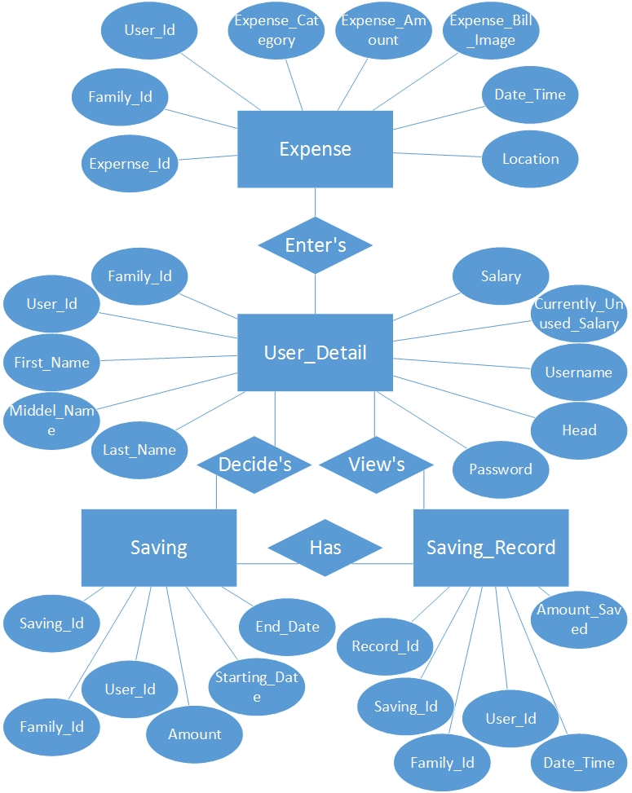

**6. ScreenShots**

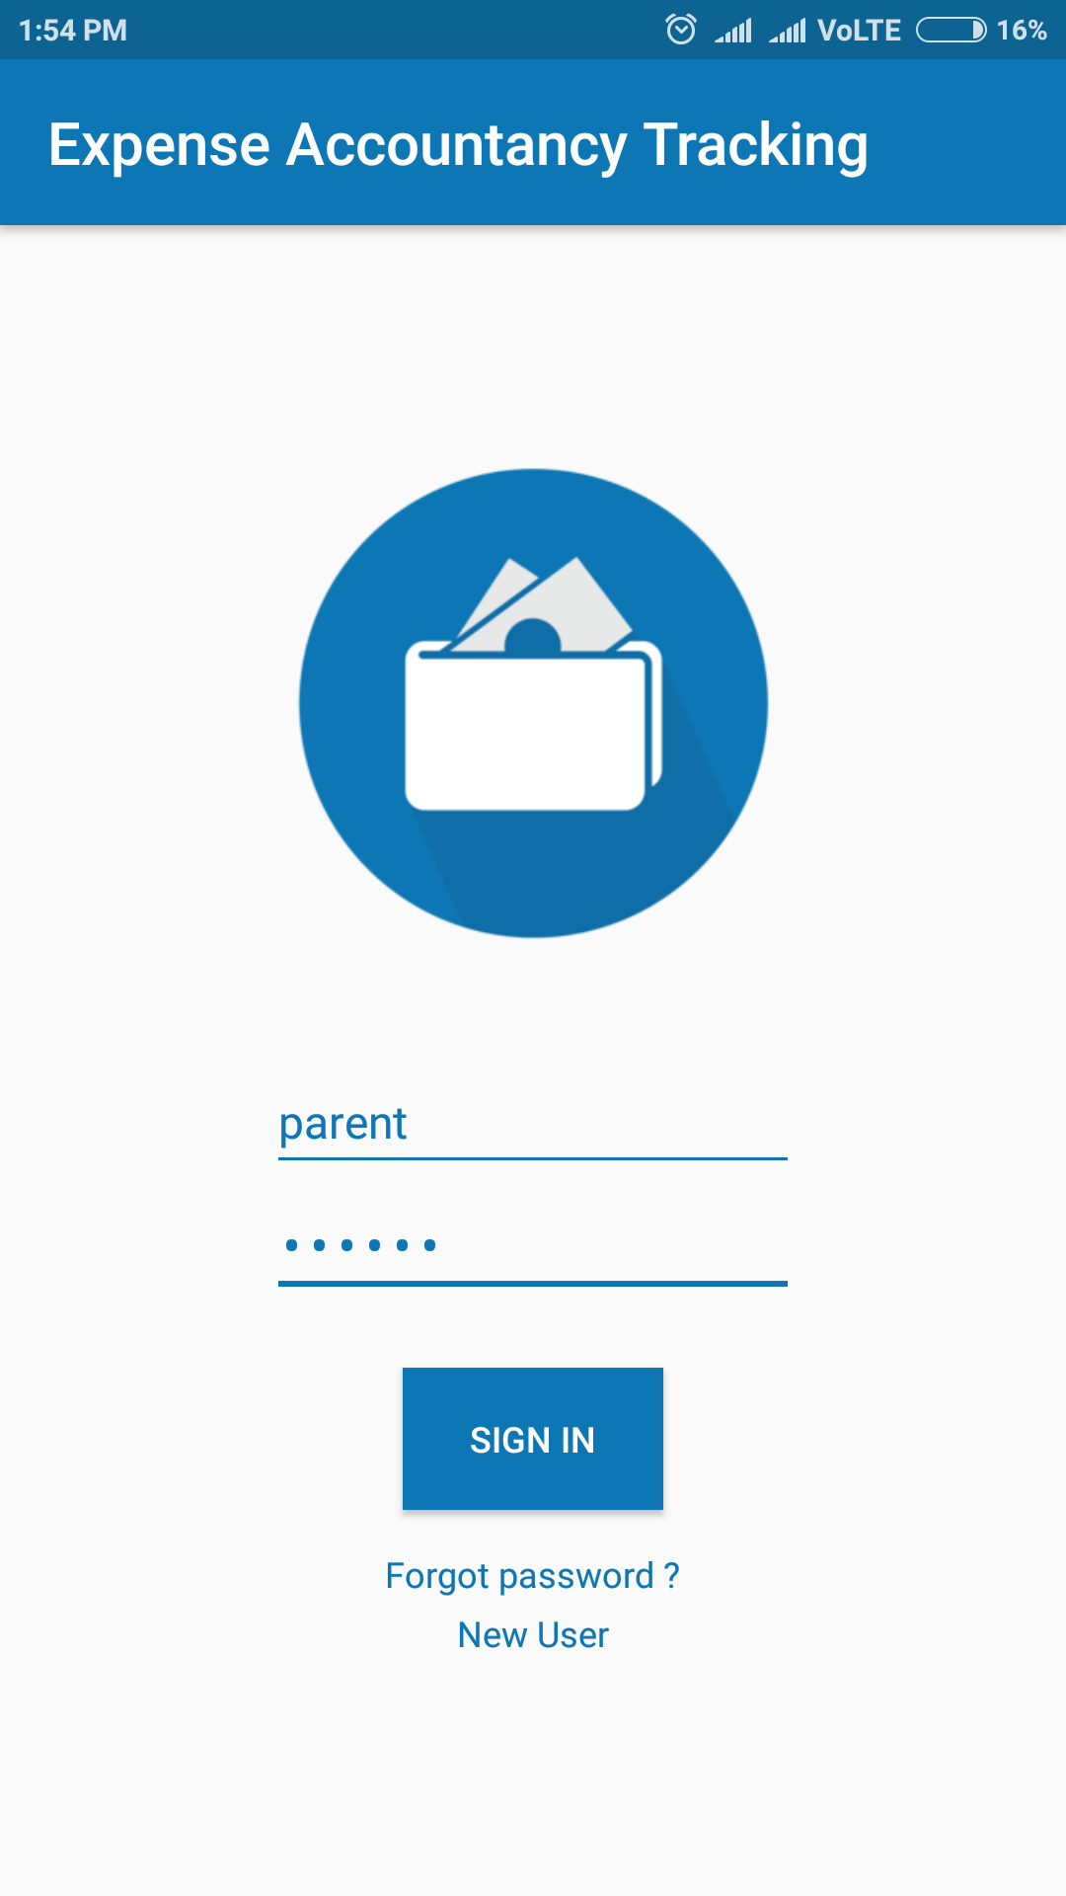

Login Screen

*Forgot Password Screen*

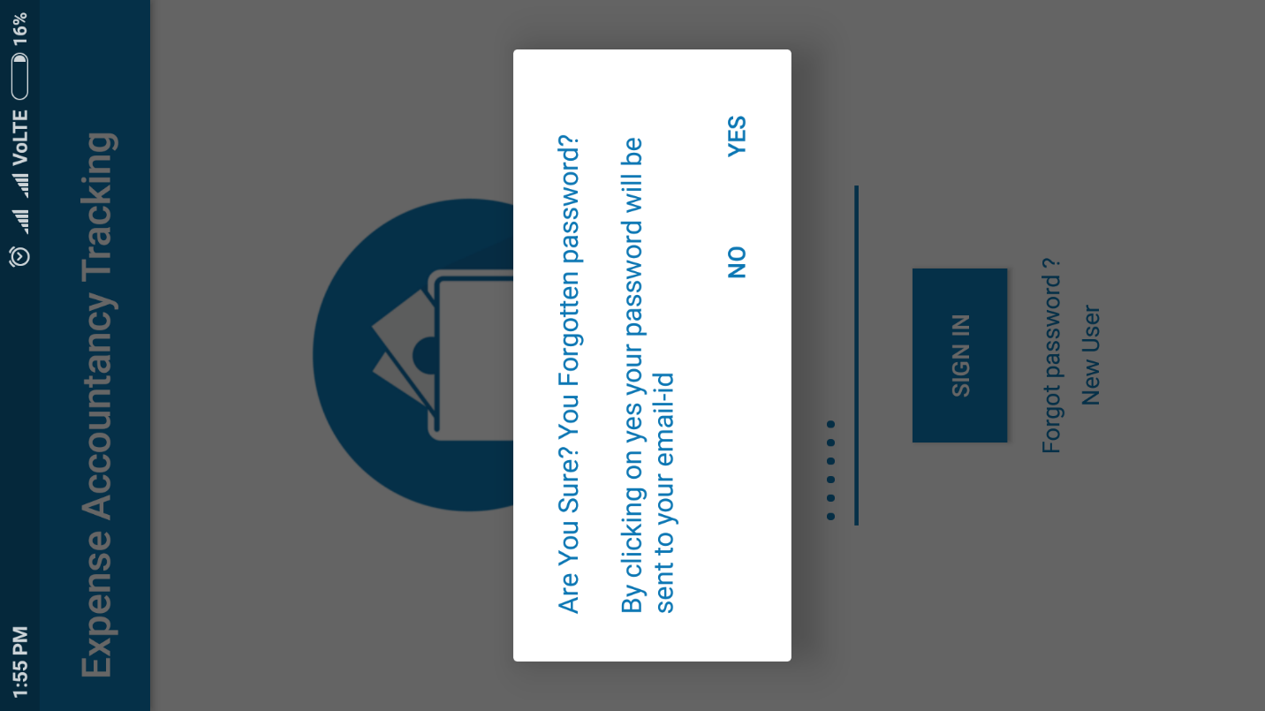

*Registration Screen*

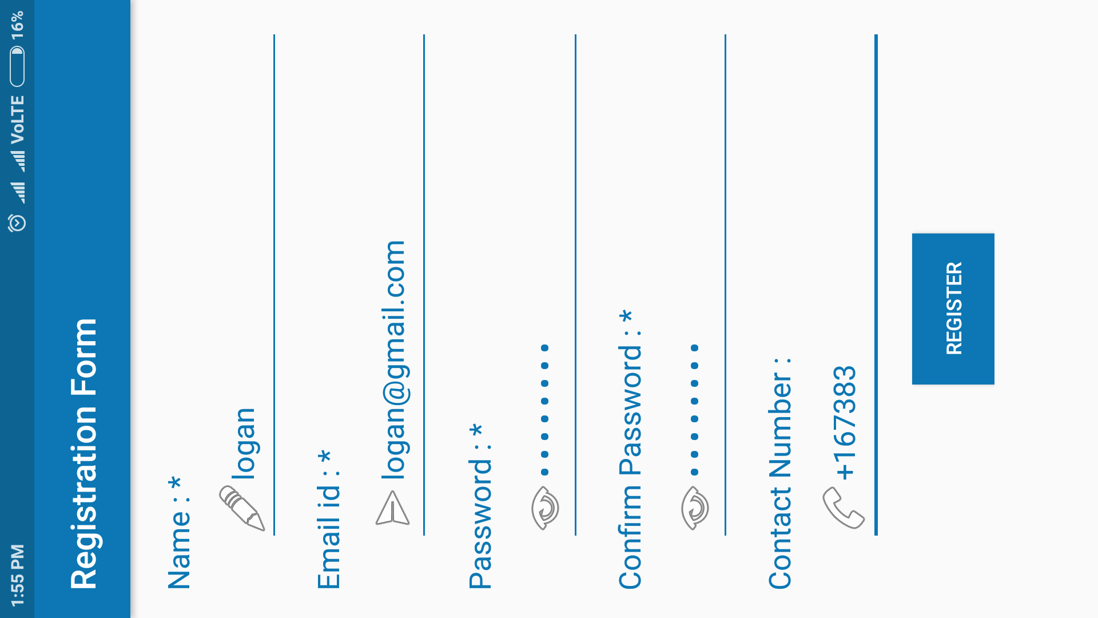

*Home Screen*

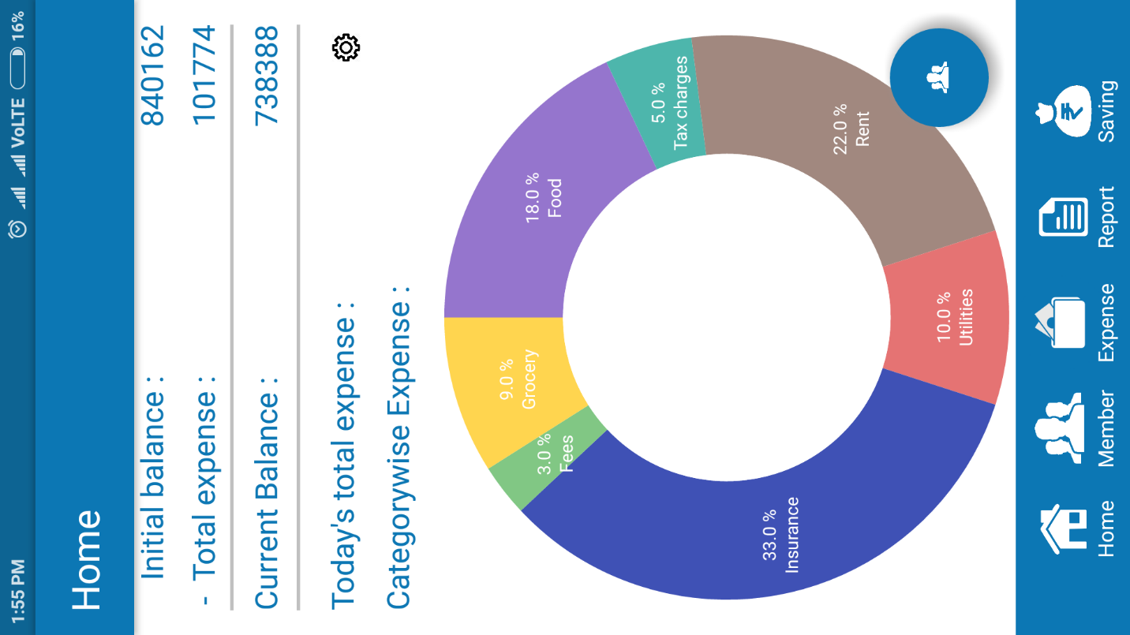

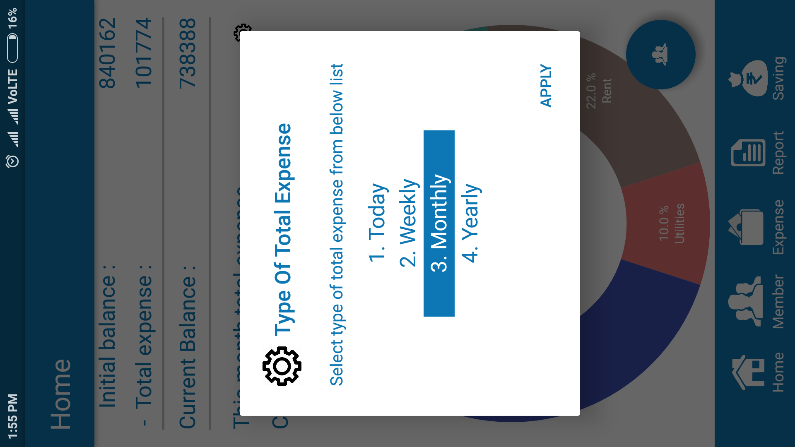

*Settings Screen*

*Member Screen*

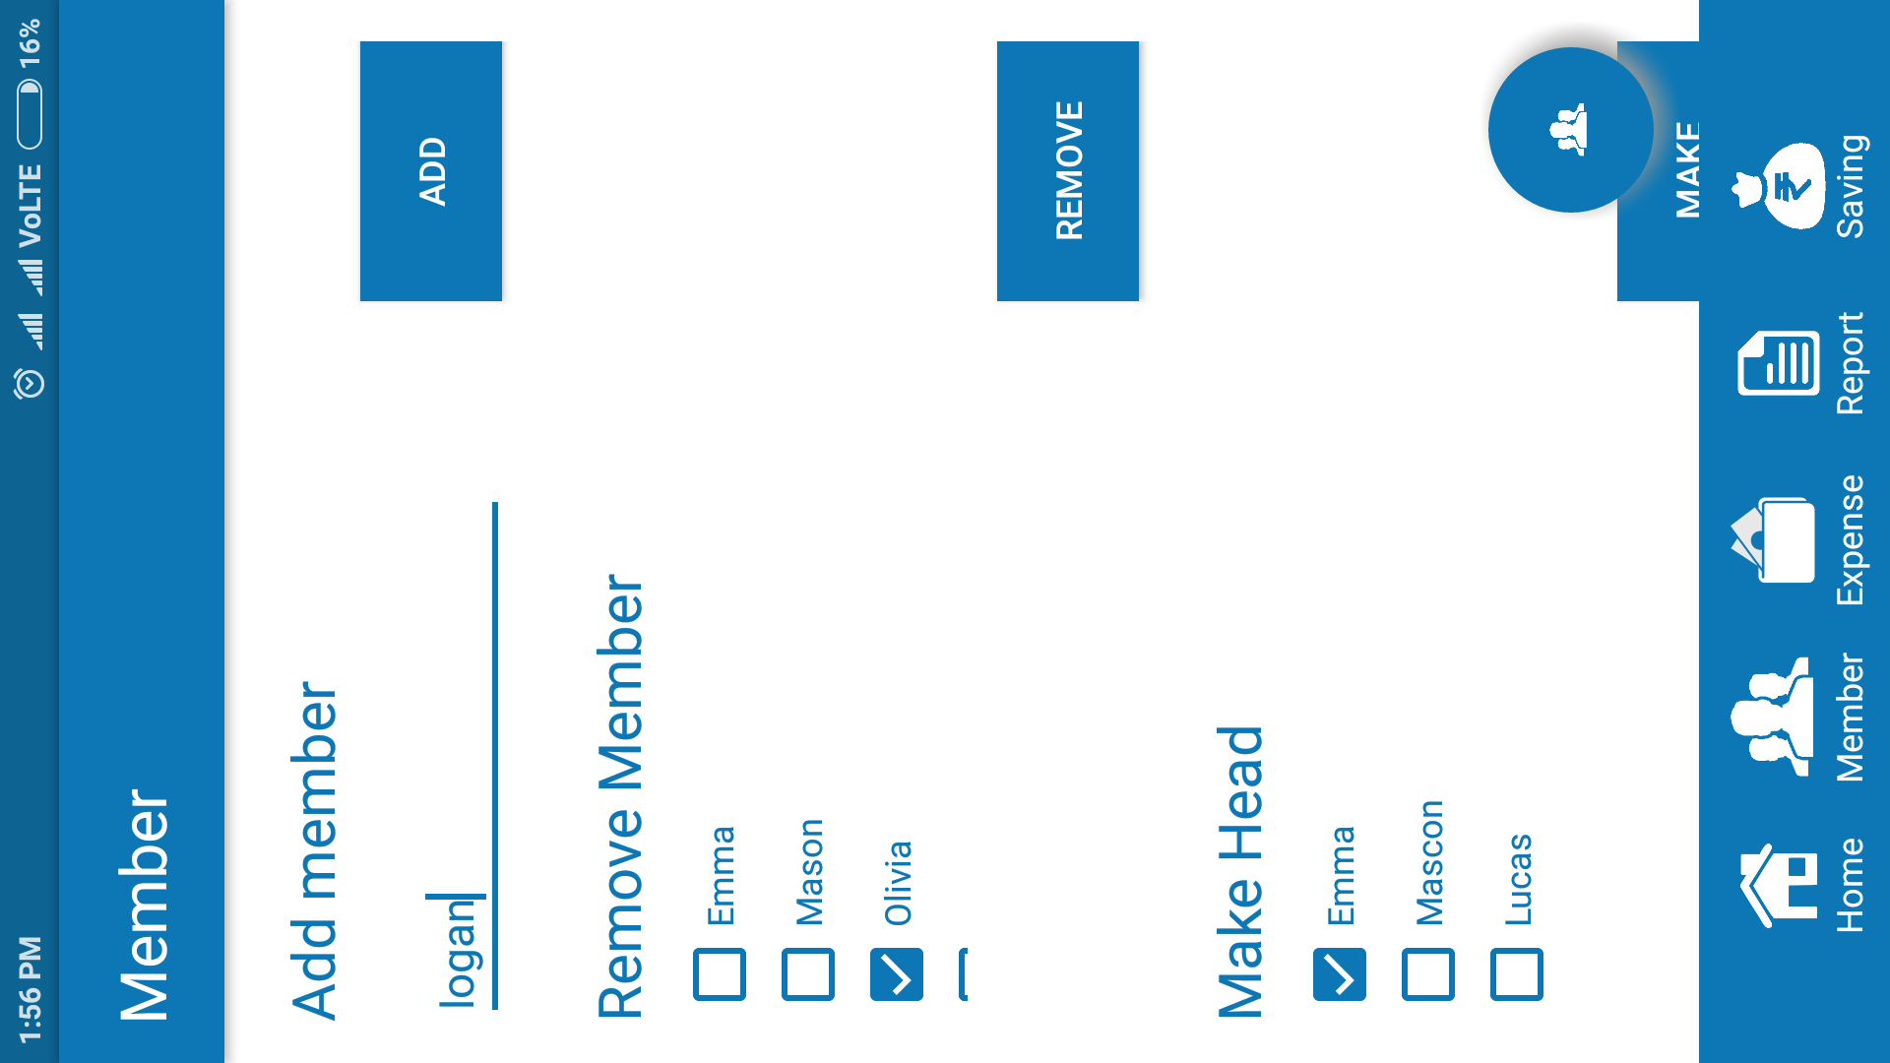

*Add Expense Screen*

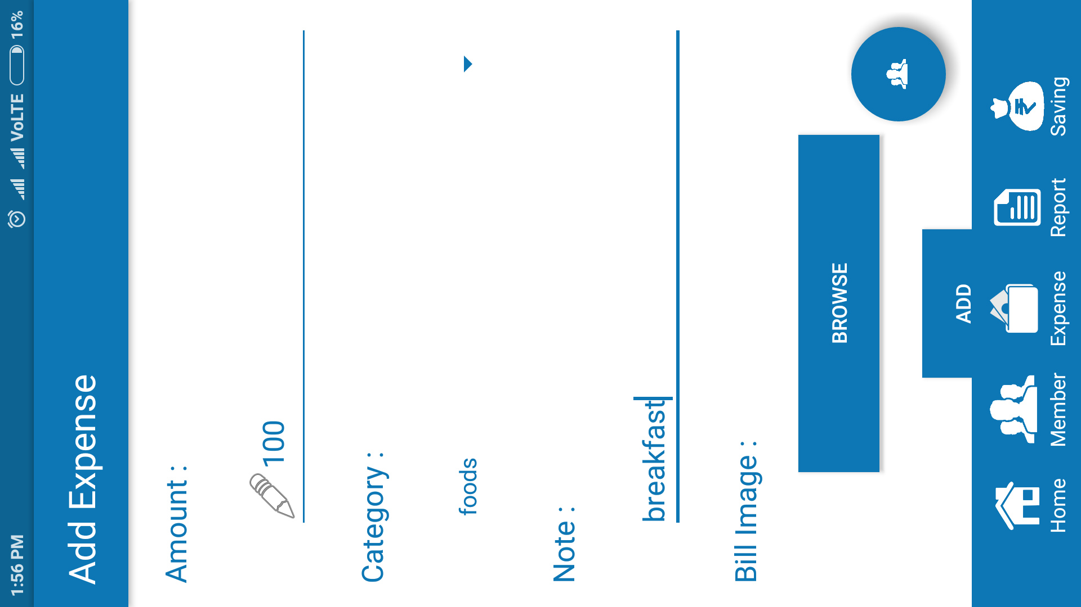

*Browse Bill Image Listner Screen*

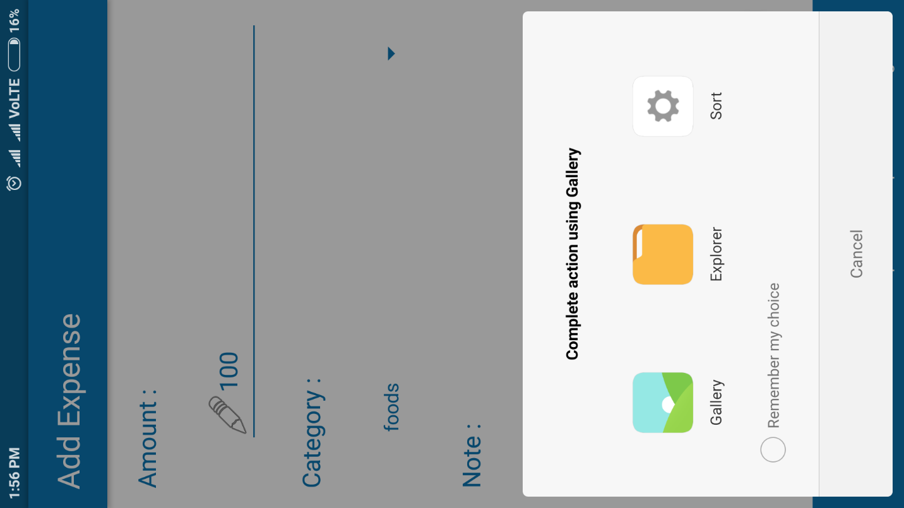

*Savings Screen*

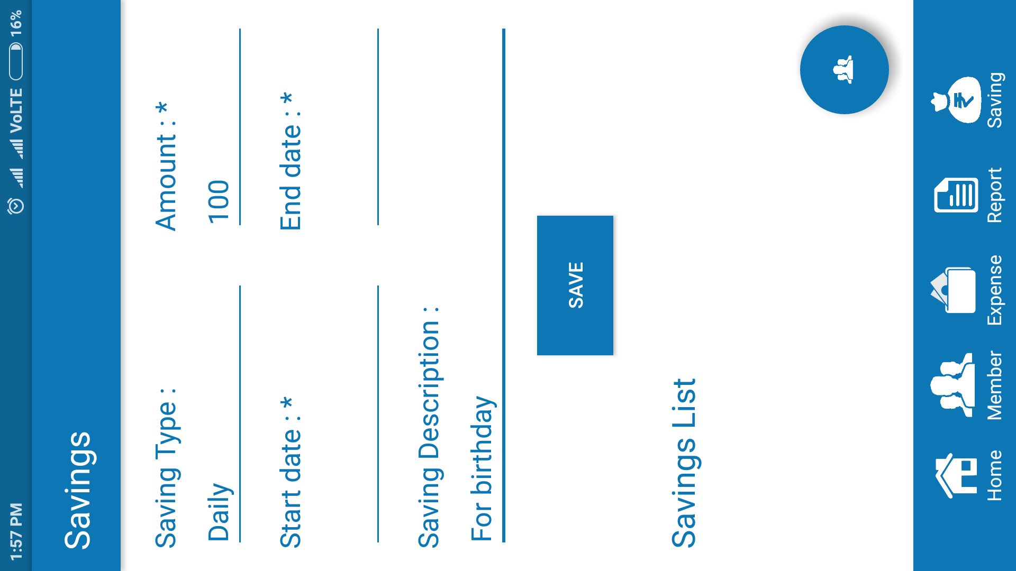

*Calander Screen*

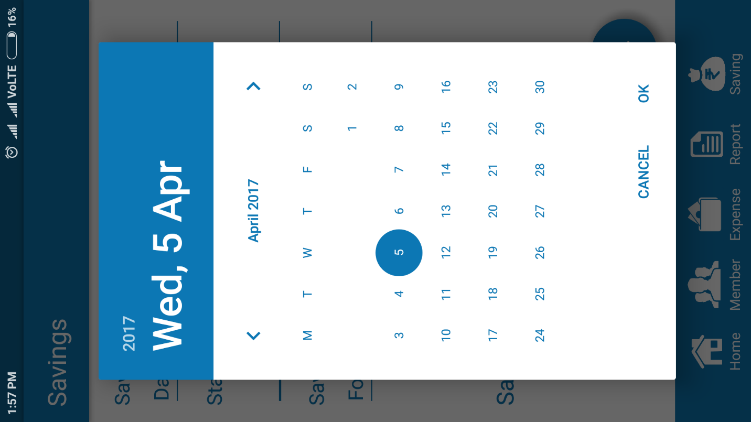

*Calander Screen*

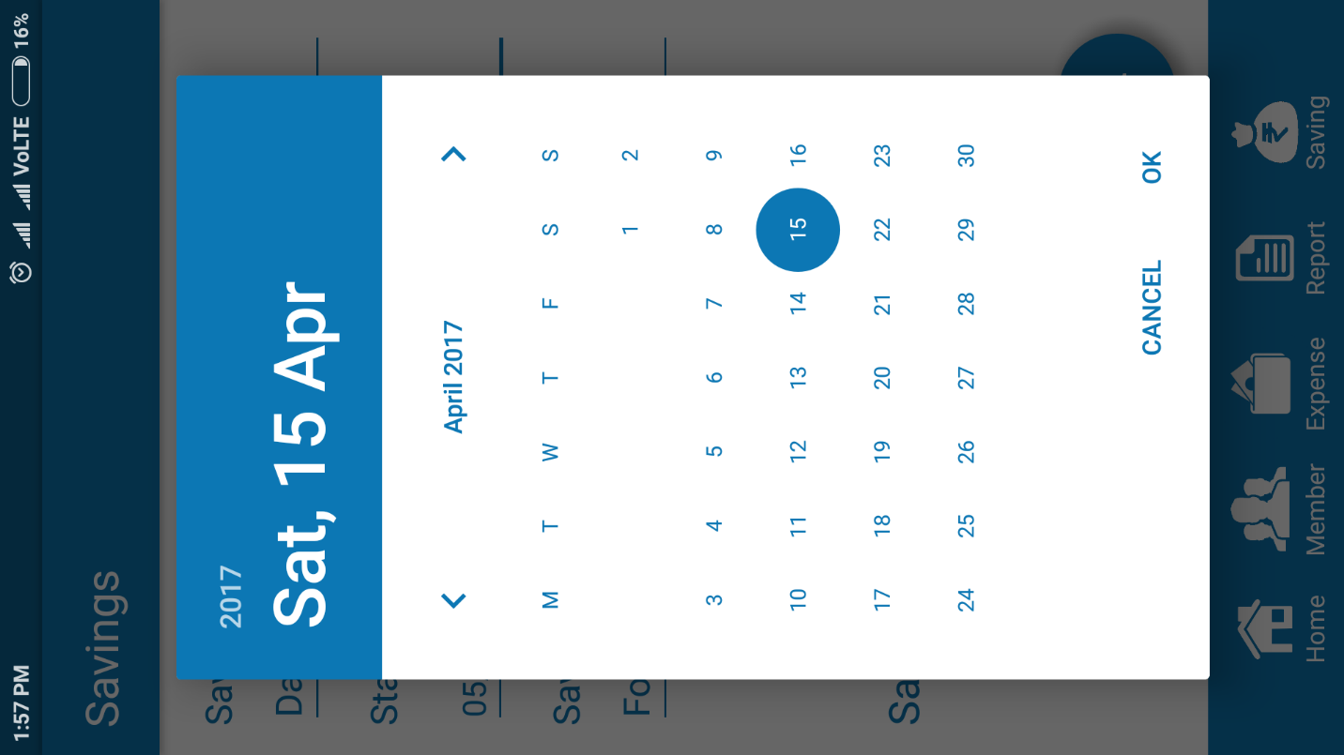

*Savings Screen*

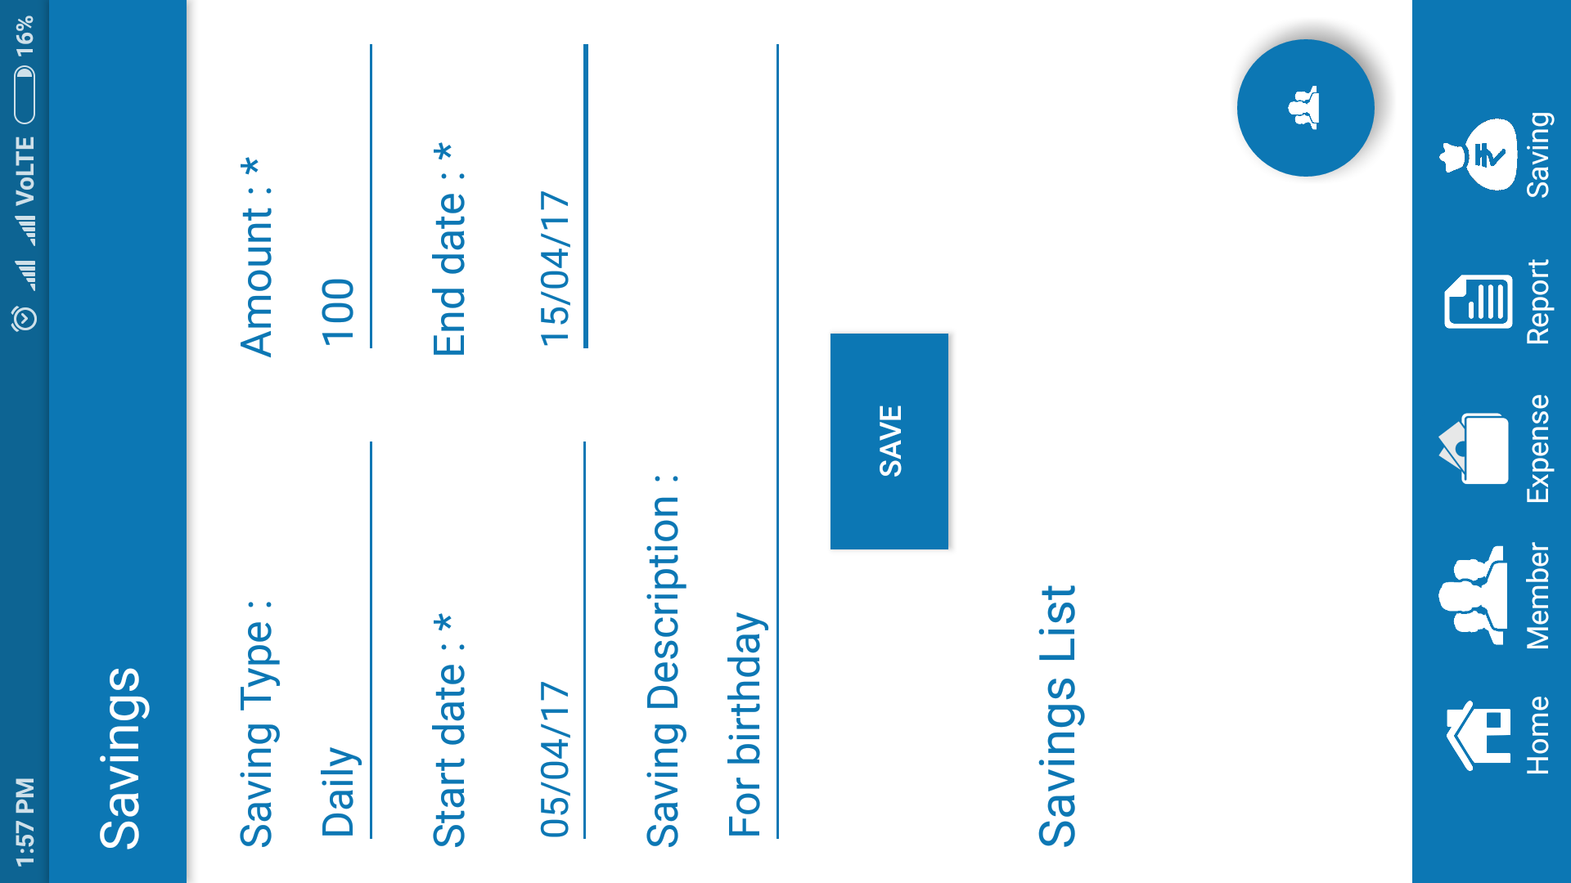

*Sending Email Screen*

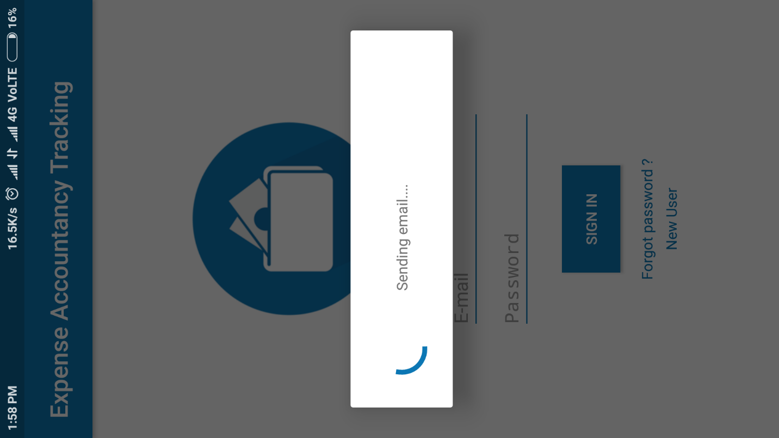

**7. Testing**

**7.1. Test cases**

Test Cases are defined to find out whether the functionality is running successfully or not and some of the test cases are mentioned below in table.

**Module Name: Login**

|  |  |  |
| --- | --- | --- |
| **Case Id** | **Test Case** | **Expected Result** |
| **CS1** | Enter username & password | Checking username and password |
| **CS2** | Unsuccessful operation due to wrong username or password | It should prompt users for invalid email or password provided |
| **CS3** | Successful login into user account | User home will display |
| **CS4** | Logout account | Logout from app |

**Module Name: Registration**

|  |  |  |
| --- | --- | --- |
| **Case Id** | **Test Case** | **Expected Result** |
| **CS1** | Enter all required information of user in registration form | Fill all Information in registration form according to requirement |
| **CS2** | Check whether the information are correct or not | Give error message if any information is wrong |
| **CS3** | Click on continue button | Continue filling information in registration form details |
| **CS4** | Click on back button | Go back to see filled Information |
| **CS5** | Click on submit button | Insert filled Information into database |

**Module Name: Edit Details**

|  |  |  |
| --- | --- | --- |
| **Case Id** | **Test Case** | **Expected Result** |
| **CS1** | Edit user’s details in edit details page | Edit information in edit details form according to user’s specified changes |
| **CS2** | Check whether the information are correct or not | Give error message if any Information is wrong |
| **CS3** | Click on save button | Update the information of user into database |
| **CS4** | Click on discard button or back button | Prompt for discard’s confirmation |

**Module Name: Forgot Password**

|  |  |  |
| --- | --- | --- |
| **Case Id** | **Test Case** | **Expected Result** |
| **CS1** | Enter valid Email id of user account | Check whether email id is valid or not |
| **CS2** | Give OTP of email id mail | Give error message if OTP is wrong |
| **CS3** | Click on submit button | Redirect to create new password of user |

**Module Name: Create family member account**

|  |  |  |
| --- | --- | --- |
| **Case Id** | **Test Case** | **Expected Result** |
| **CS1** | Enter all required information of user in registration form | Fill all Information in registration form according to requirement |
| **CS2** | Check whether the information are correct or not | Give error message if any information is wrong |
| **CS3** | Click on continue button | Continue filling information in registration form details |
| **CS4** | Click on back button | Go back to see filled Information |

**Module Name: Add member to family**

|  |  |  |
| --- | --- | --- |
| **Case Id** | **Test Case** | **Expected Result** |
| **CS1** | Enter all email id and username of new member | Fill all Information in add user form according to requirement |
| **CS2** | Check whether the provided credential user exist or not | Give error message if does not exist |
| **CS3** | Click on continue button | Add user to family |
| **CS4** | Click on back button | Prompt confirmation for discarding changes |

**Module Name: Remove member to family**

|  |  |  |
| --- | --- | --- |
| **Case Id** | **Test Case** | **Expected Result** |
| **CS1** | Select member from dropdown list | Select specified user |
| **CS2** | Click on continue button | Remove user from family |
| **CS3** | Click on back button | Prompt confirmation for discarding changes |

**Module Name: Exit from family**

|  |  |  |
| --- | --- | --- |
| **Case Id** | **Test Case** | **Expected Result** |
| **CS1** | Select exit from family option | Prompt for confirmation |
| **CS2** | Click on continue button | Remove user from family |
| **CS3** | Click on back button | Discard changes |

**Module Name: Delete account**

|  |  |  |
| --- | --- | --- |
| **Case Id** | **Test Case** | **Expected Result** |
| **CS1** | Select delete account option | Prompt for confirmation |
| **CS2** | Click on continue button | Delete user’s account from app |
| **CS3** | Click on back button | Discard changes |

**Module Name: Assign head permissions**

|  |  |  |
| --- | --- | --- |
| **Case Id** | **Test Case** | **Expected Result** |
| **CS1** | Select member from dropdown list | Select specified user |
| **CS2** | Click on continue button | Assign head permissions to specified user |
| **CS3** | Click on back button | Prompt confirmation for discarding changes |

**Module Name: View Report**

|  |  |  |
| --- | --- | --- |
| **CS1** | Select Report type from dropdown list / Category of expense from dropdown list / expense name in textbox | Select specified report |
| **CS2** | Click on continue button | Prompt for starting date and ending date |
| **CS3** | Select date’s | Validate date’s |
| **CS4** | Click on submit button | Show specific report |

**Module Name: Add Expense**

|  |  |  |
| --- | --- | --- |
| **CS1** | Select Epense type from dropdown list / expense name in textbox | Select specified report |
| **CS2** | Enter expense amount | Validate amount is integer or not |
| **CS3** | Add expense bill image | Select specified image |
| **CS4** | Click on continue button | Save into database |

**Module Name: Credit money to member**

|  |  |  |
| --- | --- | --- |
| **CS1** | Select member from dropdown list | Select specified member |
| **CS2** | Enter amount | Validate amount is integer or not |
| **CS3** | Click on continue button | Prompt for confirmation |

**Module Name: Track member**

|  |  |  |
| --- | --- | --- |
| **CS1** | Select member from dropdown list | Select specified member |
| **CS3** | Click on continue button | Show selected membersd expense |

**Module Name: Set saving target**

|  |  |  |
| --- | --- | --- |
| **CS1** | Select ending date | Select specified date |
| **CS2** | Enter amount | Validate amount is integer or not |
| **CS3** | Click on continue button | Prompt for confirmation |

**8. Limitation and Future Enhancement**

**Limitations:**

1. Very less or almost no data mining feature in app
2. Restricted use for android device user’s only
3. Family member can add wrong expense so that family head can not track use’s original expenses
4. Desktop application / Website of this system is not available

**Future Enhancement:**

1. Include data mining
2. Make app available for IOS / Blackberry as well as Windows phone platform
3. Create Desktop app as well as Website for this system

**9. Conclusion**

This project has turned out to be challenging in many ways. Each stage has presented its own problems to be overcome.

This is design with keeping quality assurance at extreme the system is developed with the latest technology. With the aspects of Visual Studio generates by various utilities with keep ahead from the current area.

The documentation for the system is developed in the view of reengineer purpose, and the ability of system to prove efficiency in timely manner for very long period.

**10. Bibliography and References**

The following software and website we have used.

* + - * <http://www.W3Schools.com>
      * <http://www.google.com>
      * <https://www.tutorialspoint.com/>
      * <https://developer.android.com/studio/index.html>
      * <https://thenewboston.com/videos.php>
      * <https://en.wikipedia.org>
      * <http://www.uml.org/>
      * <https://www.youtube.com/>
      * Android Studio
      * Microsoft Visio 2016
      * Microsoft Office 2016